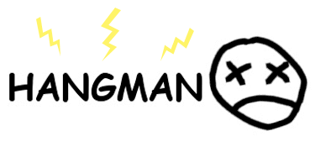

Hangman

BENJAMIN PEARLSTONE, CASEY TIN

Sections b57, b54

CS110-b1

professor rose williams

FALL 2016

CS 110 Project

“Hangman”

Benjamin Pearlstone and Casey Tin

Section B57, Section B54

“Hangman” is a simulation of the classic Hangman guessing game. It is meant for two or more players. On the Welcome screen, one of the players enters a word to be guessed. Once that word is entered, the game can be started and the other player(s) will try to guess that word.

1. Welcome Screen – ‘Welcome to Hangman!’

One of the players, the ‘initial player’, will think of a word for the other players to guess. The initial player will enter that word in order to start the game. The game will not start until a valid word is entered.

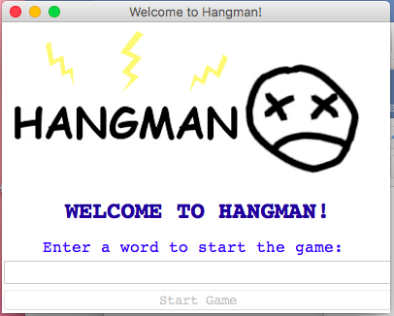

Welcome screen that appears when program is run

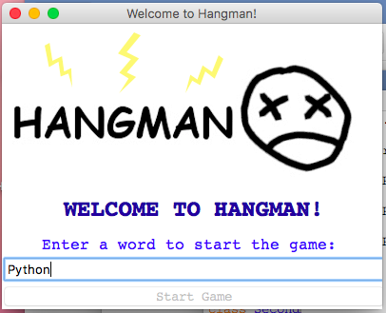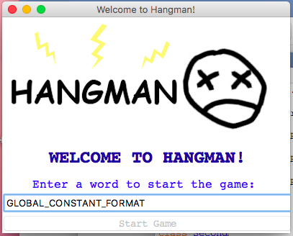

Example of invalid word input from initial user Example of valid word input from initial user

(Start Game button will not work) (Start Game button will work when valid word is entered

1. Game Screen – ‘Playing: Hangman’

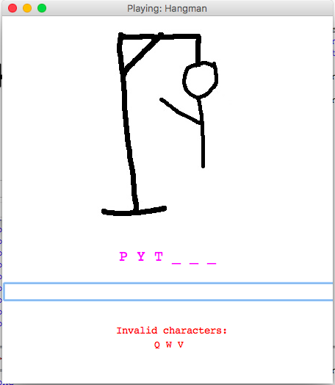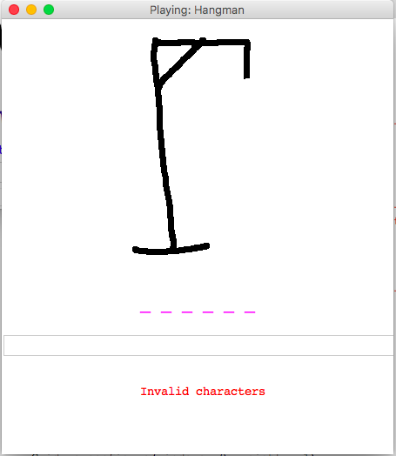This window allows the other player(s) to play the game. The only hint provided is the number of letters in the word to be guessed. In the entry box, the other player(s) can guess as many letters as they want, until they hit the maximum amount of errors. Every time an incorrect letter is guessed, a body part is added to the gallow; the maximum amount of errors is 7 for each corresponding body part.

Initial game screen Game screen when 3 incorrect characters are inputted

1. Message for Winner

This is a popup box that appears when the other players have won the game. It provides the option of playing the game again or quitting the program entirely. If the user wants to play again, they can click the ‘Yes’ button and the game will reset; if the user does not want to play again, they can click the ‘No’ button and the game will exit.

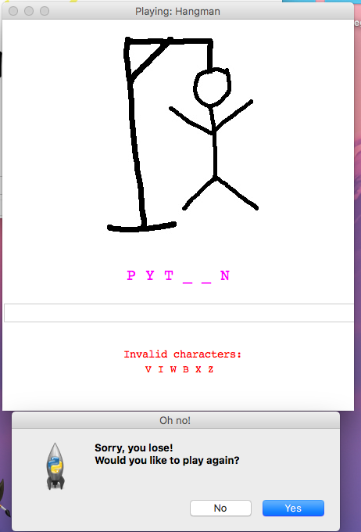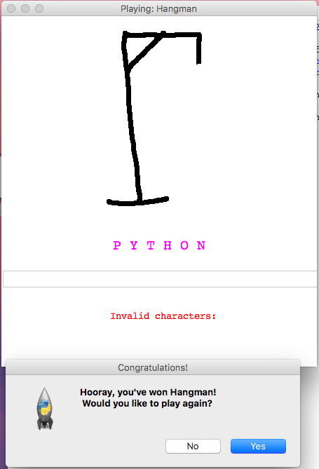

1. Message for Loser

This is a popup box that appears when the other players have lost the game. It provides the option of playing the game again or quitting the program entirely. If the user wants to play again, they can click the ‘Yes’ button and the game will reset; if the user does not want to play again, they can click the ‘No’ button and the game will exit.